**Closing Files on the WinMax Control using REST API**

Hurco Companies, Inc.

**Record of Changes**

|  |  |  |  |
| --- | --- | --- | --- |
| Rev. | Revision Description | Rev By | Date |
| 1 | Original Release | Jesse Satterwhite | 2019.7.23 |
|  |  |  |  |
|  |  |  |  |
|  |  |  |  |
|  |  |  |  |
|  |  |  |  |
|  |  |  |  |
|  |  |  |  |
|  |  |  |  |

**Introduction**

This document covers the process for remotely closing part programs and other proprietary files on the WinMax control from a connected application using REST API. The document refers to the software provided in the sample integration package and requires an established connection following the procedure outlined in the document **Connecting to the WinMax Control using a VendorID and REST API.docx**. This command is only available on Mill machines running v10.02.131 or higher control software and on Lathe machines running v11.01.311 or higher control software.

**Remote Command Request API**

The remote file closing process uses a generic remote command request API that sends a command index to the WinMax control (203 for the close command) with an array of 5 string arguments and 10 double arguments.

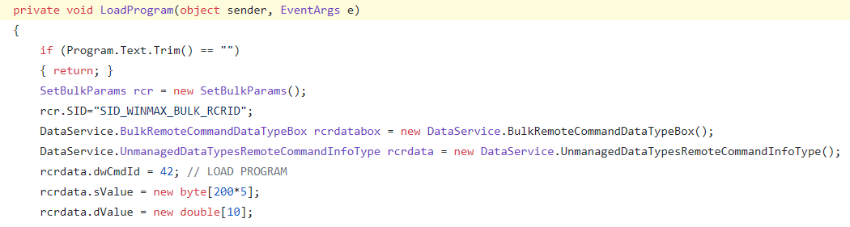

=203;

**Closing Part Programs**

* The file can have any extension that is not reserved for another known file type used by the WinMax system. As long as the WinMax has loaded a program and that program can be found in the program manager, it can be closed with the remote close command.
* 1st string argument (rcrData.sValue[0]) – Full file path and name in the form of an ASCII string that is fewer than 200 characters. The other string arguments are unused.  
  
* All other string arguments are reserved for potential future use.
* All double arguments are reserved for potential future use. Default values of 0 are recommended to avoid unexpected changes in behavior in the event of future WinMax software upgrades.